**Ring Interlock Circuit**

**Introduction**

In the pursuit of safe and efficient electric vehicle (EV) charging infrastructure, the evolution from sequential circuits to ring interlock circuits marks a significant advancement. The transition is driven by the imperative to enhance power sharing capabilities while mitigating potential risks, such as short circuits that could lead to hazardous situations including fires.

Previously, sequential circuits comprised four modules with two ports each, facilitating the connection of vehicles to the charging system. However, inherent limitations in sequential configurations necessitated a paradigm shift towards ring interlock circuits, wherein the safety and efficiency of EV charging systems are significantly augmented.

The fundamental principle guiding the development of ring interlock circuits is twofold: power sharing and prioritization. In essence, the system orchestrates the allocation of power among connected vehicles dynamically, ensuring equitable charging while accommodating varying demands. This innovation enables seamless integration of multiple vehicles into the charging infrastructure, fostering scalability and adaptability to evolving needs.

Central to the design philosophy of ring interlock circuits is the preservation of safety. Unlike sequential circuits, where the risk of short circuits between vehicles posed a formidable challenge, ring interlock configurations mitigate this risk by enforcing a strict prohibition on short paths between vehicles. This crucial safeguard ensures that the charging process proceeds without compromising safety or jeopardizing the integrity of the system.

Moreover, the modular nature of ring interlock circuits empowers operators to customize charging priorities based on user preferences and operational requirements. By allocating higher priority to specific vehicles, such as those in urgent need of charging, while maintaining equitable access for all users, the system optimizes resource utilization and enhances user satisfaction.

**Comparison between Previous Sequential Circuit and Ring Interlock Circuit:**

**Previous Sequential Circuit:**

1. **Topology:** The previous sequential circuit comprised a linear topology, with four modules arranged sequentially. Each module featured two ports for connecting vehicles.

2. **Operation:** Vehicles were connected to the ports of the modules sequentially, resulting in a linear flow of power through the system. Charging prioritization was limited, typically following a first-come, first-served basis.

3. **Constraints:** One of the primary constraints of the sequential circuit was the potential for short paths between vehicles, leading to safety hazards such as short circuits and fire risks.

4. **Logic Development:** The logic governing the operation of the sequential circuit was relatively straightforward, primarily focusing on managing the sequential flow of power to connected vehicles. Safety protocols were limited to basic measures to **prevent short circuits.**

F

E

D

C

B

A

Here A, B, C, D, E and F represent the feedbacks of modules

(contactors) & $A^{-1}, B^{-1}, C^{-1}, D^{-1}, E^{-1}and F^{-1}$ represent the current input status.

$$A→{\left(ABCDEFA^{-1}\right)}^{-1}$$

$$B→{\left(ABCDEFB^{-1}\right)}^{-1}$$

$$C→{\left(ABCDEFC^{-1}\right)}^{-1}$$

$$D→{\left(ABCDEFD^{-1}\right)}^{-1}$$

$$E→{\left(ABCDEFE^{-1}\right)}^{-1}$$

$$F→{\left(ABCDEFF^{-1}\right)}^{-1}$$

**Ring Interlock Circuit:**

1. **Topology**: The ring interlock circuit features a circular or ring-shaped topology, with four modules interconnected in a closed loop. Each module retains four ports for vehicle connection.

2. **Operation**: In contrast to the linear flow of power in the sequential circuit, the ring interlock circuit enables dynamic power sharing among connected vehicles. Charging prioritization is enhanced, allowing for the allocation of higher priority to specific vehicles based on user requirements.

3. **Constraints**: The ring interlock circuit addresses the safety concerns of the previous sequential circuit by enforcing strict prohibition on short paths between vehicles. This significantly reduces the risk of short circuits and associated safety hazards.

4. **Logic Development**: The logic development for the ring interlock circuit is more intricate compared to the previous sequential circuit. It involves algorithms and protocols for dynamic power allocation, prioritization of charging, and stringent safety measures to prevent short paths between vehicles.

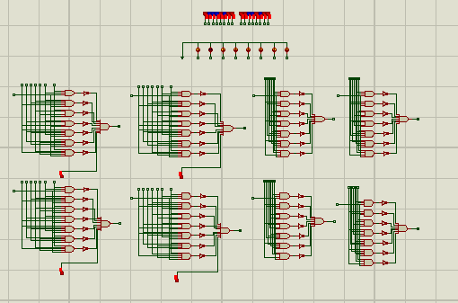

-Contactors

* Ports